Company Dash tasks agents and handoffs
Document 33 of the Nexora learning guides
Source snapshot 14 October 2026 at 06:41 UTC
Follow a request from its form through a specialist run and a reviewed handoff.

Recognise the screen and its scope
Open http://127.0.0.1:8000/#work, http://127.0.0.1:8000/#agents. Company Dash uses loopback port 8000 and hash navigation. Open its separate repository in VS Code before Ctrl+P. The source library uses company-dash as a project label, not a Nexora folder.
This guide covers Work board and filters; Six specialist roles; Linked workflows; Conversations and reports; Queued runs cancellation and restart recovery.
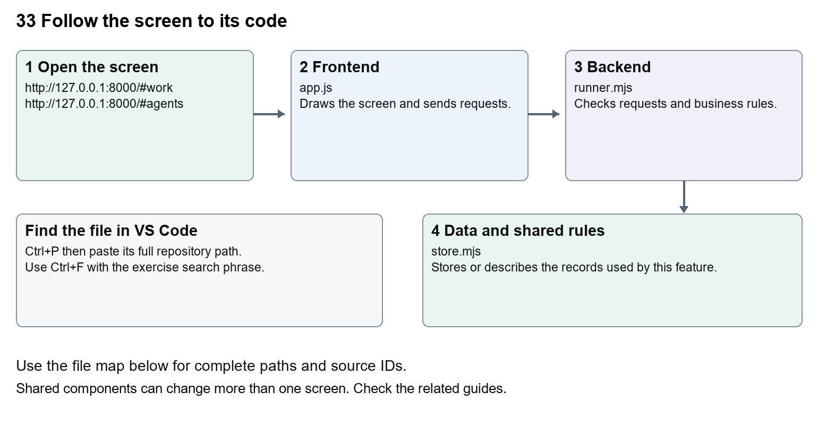
The diagram shows the file roles. The full paths below are what you paste into Ctrl+P.

Find the files in VS Code
Role | File and source ID | What it does
Screen | S0696 app.js | Main UI or route for this topic
Server | S0710 runner.mjs | Endpoints or server rules
Data | S0711 store.mjs | Data shape or persistence structure

Screen S0696
public/app.js
Server S0710
server/runner.mjs
Data S0711
server/store.mjs
Use the HTML source buttons for full files. Word shows labelled extracts; individual Markdown guides contain complete primary files.

Follow the request and the records
1. The request form sends title, description, agent, area, priority and workflow choice to POST /api/tasks.
2. The server validates the fields and stores tasks and initial messages in a SQLite transaction.
3. A linked workflow creates dependent tasks; each waits for the previous accepted handoff.
4. Starting a role queues a serial run in an isolated source workspace and stores logs and artifacts.
5. The operator reviews a structured report, requests revision or accepts the handoff to unlock the next role.

Read the code with an explanation
The six roles are PM, BA, CRM Developer, Portal Developer, QA and Nexora Support Agent; catalog.mjs defines their names and instructions. PM, BA and Support use read-only execution, while Developer and QA write inside their isolated workspaces. Support defaults to standalone triage. Selecting a linked workflow creates a fixed sequence, not autonomous planning or automatic execution. store.mjs creates tasks, messages, runs, artifacts, events and metadata tables. A report in review is distinct from an accepted task, a passed test or applied code.
Source reference S0696 company-dash/public/app.js
Extract from source line 47. A fragment from a long line is shown without the rest of that line.
0047 function work() {

index.html supplies markup and app.js renders browser views. Follow api() to the server route handler.
Source reference S0710 company-dash/server/runner.mjs
Extract from source line 42. A fragment from a long line is shown without the rest of that line.
0042 enqueue({ task, suite, targetTask, prepareRuntime = task?.agent === 'qa' }) {

The browser api() helper sends a method and local request token. app.mjs checks the route and calls the relevant service. Follow that call to understand SQL writes, process execution and filesystem changes.
Source reference S0711 company-dash/server/store.mjs
Selected opening lines with their original numbers. The complete file is in the HTML source library.
0001 import { DatabaseSync } from 'node:sqlite';
0002 import fs from 'node:fs';
0003 import path from 'node:path';
0004 import { randomUUID } from 'node:crypto';
0005 import { usageParser } from './usage.mjs';
0007 export const now = () => new Date().toISOString();

store.mjs defines SQLite history tables. catalog.mjs and config.mjs define configuration; repository.mjs records fingerprints. Trace each key into its service before assuming it is a stored table.

Make or trace your first change
1. Press Ctrl+P and open public/app.js.
2. Press Ctrl+F and search for function updateWorkflow(). In this snapshot it appears at line 84.
3. Read-only exercise: find which roles can create a workflow and why Support starts with it unchecked. Trace Accept handoff to the server and identify the dependent-task update without clicking it.
4. Record the file, request path and server handler you found. This exercise is read-only; no stored records need to change.
Extract from source line 84. A fragment from a long line is shown without the rest of that line.
0084 function updateWorkflow() { const eligible=['pm','ba','support'].inclu

These exercises have not been applied to the application. Their search phrases are verified against the captured source. Line numbers can move; the phrase and file path are your main navigation aids.

Check a change and diagnose problems
Confirm the original screen still loads, the changed words appear in the intended place, and another screen using the same component still behaves correctly. If an action fails, inspect the browser Network response, the relevant helper and server validation message. Use the common error table at the beginning of the manual. Reload on a version conflict instead of removing the version check.
A syntax error after a text edit usually means a quote, brace or closing tag changed. Compare your diff with the original. An unchanged browser result can mean the wrong port, a saved published configuration overriding a default, or a running API that has not reloaded.

Understand the current limits
Agent runs use the signed-in Codex provider and account limits. They may be blocked by missing dependencies or usage limits. Restarted unfinished runs are marked interrupted; inspect their logs before retrying. This chapter exercise creates no real tasks or customer messages.

Continue learning
Related guides 32 Company Dash repository and source viewer, 34 Company Dash QA and verification, 35 Company Dash proposal review and integration, 36 Company Dash history backups and settings.

